Operational Process on How to Cooke Oatmeal.
Name
Institution
Date

Operational Process on How to Cooke Oatmeal.
Executive Summary
Oatmeal are basically foods that are taken as breakfast since they are light foods. Also, Oatmeal's are healthy foods that impact our health positively. For instance, Oatmeal's are highly nutritious; also, whole Oatmeal is rich in Antioxidants, oatmeal contains a strong soluble fiber known as the Beta-Glucan, and finally, Oatmeal improve the health of the body by maintaining the required level of blood sugar.
Introduction.
Oatmeal falls under the category of healthy meals that may contribute to reducing obesity among individuals. Most of the oatmeal are taken during breakfast since they are light foods. In addition to Oatmeal, it's a very healthy meal that gets one's motor functioning throughout the day if undertaken by an individual as well as it can be a very delicious meal if made well (Mackie et al., 2017). Oatmeal is highly associated with significant benefits. Such benefits of consuming or taking Oatmeal as a breakfast include- oatmeal are highly nutritious; also whole Oatmeal is rich in Antioxidants, oatmeal contains a strong soluble fiber known as the Beta-Glucan, Oatmeal improve the health of the body by maintaining the required level of blood sugar, and finally Oatmeal aids people who have issues associated with obesity lose their weight. Consumption of Oatmeal aids in reducing the risks of heart diseases that have become more prone to peoples.
Tools Analysis to Use in Cooking Oatmeal.
In order to develop a basic recipe for cooking Oatmeal, one has to be fully equipped with various tools that will enable one to progress smoothly without difficulties. Therefore, all the requirements one needs in order to come up with his or her own Oatmeal, especially at the homestead, include the Oatmeal itself, the salt and sugar in case one wants to make the Oatmeal sweet, and finally bags that sealable for storing the Oatmeal (Wack, 2018). The main purpose served by salt is to enhance flavor among foods. Thus the use of salt in the cooking or preparation of Oatmeal tends to bring out the inherent but subtle sweetness and nuttiness of the oat. In the Oatmeal preparation, it is always advisable to only add low-calorie sweeteners or a small amount of sugar, considering that the use of more-calorie sweeteners such as honey significantly contributes to raising the blood glucose level within one's body.
Flow Chart on How to Prepare Oatmeal.
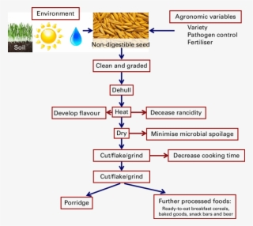
(diagram curtesy of nicepng)
The Operational Process.
The process of preparing the Oatmeal is easy. Such a procedure of preparing Oatmeal commences by adding some amount of Oats to the sealable bag, preferably a quarter of a cup. The next step is taking some salt, preferably one teaspoon, and put in a separate bag with the Oats (Lee et al., 2018). The other step entails pre-adding a small quantity of sugar, preferably of about half a teaspoon, to enhance the Oatmeal's sweetness. Adding sugar depends on the individual preparing the Oatmeal since one can choose to add some amount of sugar or none. After preparing the Oatmeal, one can either to flavor it or not. If one decides to flavor the Oatmeal, various ingredients are required, as depicted in the diagram below.
Flavoring the Oatmeal.
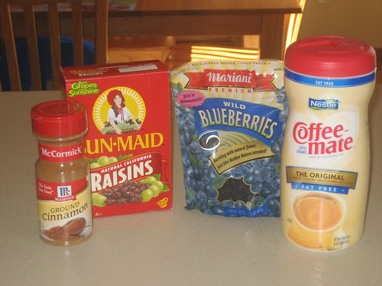
The ingredients to use in flavoring, which is on the left-hand side, are for cinnamon-raisin, while the ingredients on the right-hand side are for blueberries and cream. The blueberries used as ingredients for flavoring should be dry and fat-free. Making the blueberries dry aids to do away with bad effects when left in bags for too long. In the cinnamon-raisin ingredient case, add like a quarter of a teaspoon to the bag the Oatmeal is in. For the blueberries ingredient, add like a tablespoon in the bag containing the Oatmeal.
Oatmeal Flavored with Blueberries.
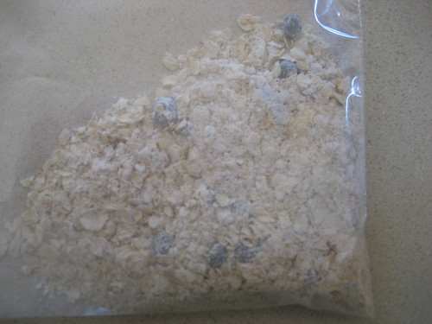
The addition of the flavored ingredients contributes to the improvement of the taste. It is also advisable to incorporate a high-quality version of the ingredients used in flavoring the Oatmeal. For instance, the parched blueberries in such bags are way improved than the blueberries used in the Quaker Oats packages, resulting in considerably tastier blueberry oatmeal (Wack, 2018). In the case of storing the Oatmeal, it is always advisable to store them in a thick baggie.
Sells or Cost Analysis.
The batch used in the making of the Oatmeal baggies normally attributes to forty-eight bags if well utilized. Usually, one can make forty-eight baggies out of the legalized normal-sized canister of instant oatmeal. From the Oatmeal preparation I have prepared, fifteen of the baggies contained ingredients of blueberries used as a flavor, and twenty-seven of the baggies contained cinnamon-raisin ingredients. The time cost I used in preparing the Oatmeal is about thirty-five minutes. Concerning the recommendations with the proposed process that aims to reduce the costs, it is more important not to optimize flavored ingredients. As a bit of optimization shaves off a lot of the cost. Another improvement that will contribute to saving on the cost is maximizing purchasing a giant canister of the Oatmeal instead of buying small amounts of the canister.
Moreover, purchasing the oatmeal in large amounts or as a wholesale cuts down on each packet's cost considerably. Similar logic relates to some of the flavored constituents. For instance, when you particularly become interested in blueberries in your oatmeal, purchasing them in large quantities aids in cutting down on costs, too. In conclusion, making one's Oatmeal is a cost-saver. Most of the oatmeal are taken during breakfast since they are light foods. In addition to Oatmeal, it's a very healthy meal that gets one's motor functioning throughout the day if undertaken by an individual as well as it can be a very delicious meal if made well.

References
Mackie, A. R., Bajka, B. H., Rigby, N. M., Wilde, P. J., Alves-Pereira, F., Mosleth, E. F., ... & Salt, L. J. (2017). Oatmeal particle size alters glycemic index but not as a function of gastric emptying rate. American Journal of Physiology-Gastrointestinal and Liver Physiology, 313(3), G239-G246.
Wack, M. F. (2018). Recipe-Collecting, embodied imagination, and transatlantic Connections in an irish emigrant’s Cooking. The Canadian Journal of Irish Studies, 41, 100-123.
Lee, Y., Kim, D. S., Jung, E. K., & Joo, N. (2018). Development of cookies with brewer's yeast and beans to improve skin health of lactating women. Journal of the Korean Dietetic Association, 24(1), 31-47.

